

**19CSE102 – Computer Programming Project**

**(CCE - Group 6)**

**GROUP MEMBERS:**

|  |  |  |
| --- | --- | --- |
| S.NO | NAME | ROLLNO. |
| 1. | Akshara R | CB.EN.U4CCE20003 |
| 2. | Vardhan Viswanath | CB.EN.U4CCE20068 |
| 3. | Anten Cheguevara Pu | CB.EN.U4CCE20007 |
| 4. | Sadhana | CB.EN.U4CCE20010 |
| 5. | Chitraksh | CB.EN.U4CCE20056 |

**PROBLEM TITLE:**

# Covid-19 Management Using Wearable Sensors

**PROBLEM DESCRIPTION:**

Create an interface with sensor readings to detect Covid-19, and perform the following:

* Find out the number of persons with high temperature based on the standard temperature score.
* Collect the day-wise details of people residing in a geographical area (say for a week). Find out the count of persons who are ill and if it’s increasing day-by-day to the severity of the disease.
* Covid-19 probability detection, indicate the probability of a person to have covid-19 such as “high probability”, “medium probability”,” low probability”.

CONCEPTS USED:

* **STRUCTURES:** *(struct record)*

Used structures to declare age, gender and 5 parameters to detect covid of different data types.

* **LOOPS:** *(for, while and do-while)*

Used to implement conditions and detect illness for a group of people for a week.

* **ARRAY:** *(count [7])*

Used to store the number of people ill for a week (7 days).

* **STRINGS:**

Used strcmp inbuilt library function from <string.h> header file to compare two strings.

* **MODULES:** *(high, low, medium, child, teen, adult, severity)*

Used to categorise code based on the age group and the severity for an elegant and understandable code, and return values if necessary.

* **FILES:** *(data.txt)*

Used to collect data and store it in a text file named data.txt

FUNCTIONALITIES:

* **HIGH:** *(type – no argument, with return value)*

This function is to indicate the person is having high probabiltiy of illness which returns the value one.

* **MEDIUM:** *(type – no argument, with return value)*

This function is to indicate the person is having med probabiltiy of illness which returns the value one.

* **LOW:** *(type – no argument, no return value)*

This function is to indicate the person is having low probabiltiy of illness.

* **CHILD:** *(type – with argument, with return value)*

This function calculates the sum of abnormal values of all parameters in a child. The concepts used are: structures, string, loops and conditional statements.

* **TEEN:** *(type – with argument, with return value)*

This function calculates the sum of abnormal values of all parameters in teenager. The concepts used are: structures, string, loops and conditional statements.

* **ADULT:** *(type – with argument, with return value)*

This function calculates the sum of abnormal values of all parameters in adults. The concepts used are: arrays, string, loops and conditional statements.

* **SEVERITY:** *(type – with argument, without return value)*

This function gives data on how covid is varying from day to day. The concepts used are: structures, files, loops and conditional statements.

**CODE**

#include <stdio.h>

#include <conio.h>

#include <string.h>

#include <stdlib.h>

#include <ctype.h>

#include <math.h>

//COVID-19 SURVEY!!

// Initialising strings globally

char str_male[] = "male";

char str_female[] = "female";

char audio_yes[] = "yes";

char audio_no[] = "no";

char repeat_yes[] = "yes";

char repeat_no[] = "no";

// Using structure to declare variables of 5 parameters, age and gender!

struct record{

int age, temp, oxy, resp, hr;

char g[10], audio[10];

};

// High function is declared and defined to indicate the person is having high probabiltiy of illness.

int high(){

printf("\nYou have a 'high-probability' of being infected with covid 19!");

printf("\n\n\t\t\tTips :\nStay quarantined for 15 days and take proper care of your health!\nTake a covid test after 15 days!");

return 1;

}

// Medium function is declared and defined to indicate the person is having medium probabiltiy of illness.

int medium(){

printf("\nYou have a 'medium-probability' of being infected with covid 19!");

printf("\n\n\t\t\tTips :\nTake proper precautions and maintain social distancing \nTake a covid test after 15 days! \nUse sanitizer and mask!");

return 1;

}

// Low function is declared and defined to indicate the person is having low probabiltiy of illness.

void low(int age){

printf("\nYou have a 'low-probability' of being infected with covid 19!");

printf("\n\n\t\t\tTips :\nTake proper precautions and maintain social distancing \nUse sanitizer and mask!");

if (age>=18)

{

printf("\nGet vaccinated soon if you haven't!");

}

}

// Severity function is declared and defined to find out the variation in the number of Covid-19 cases each day.

int severity(int count[], FILE *fp){

int j, n;

for (j = 0; j <= 5; j++){

if (count[j] < count[j + 1]){

printf("The number of people who are ill is 'increased' by '%d' from day '%d' to day '%d'\n", count[j + 1] - count[j], j + 1, j + 2);

fprintf(fp,"The number of people who are ill is 'increased' by '%d' from day '%d' to day '%d'\n", count[j + 1] - count[j], j + 1, j + 2);

}

else if (count[j] == count[j + 1]){

printf("The number of people who are ill is 'neither increased nor decreased' from day '%d' to day '%d'\n", j + 1, j + 2);

fprintf(fp,"The number of people who are ill is 'neither increased nor decreased' from day '%d' to day '%d'\n", j + 1, j + 2);

}

else{

printf("The number of people who are ill is 'decreased' by '%d' from day '%d' to day '%d'\n", count[j] - count[j + 1], j + 1, j + 2);

fprintf(fp,"The number of people who are ill is 'decreased' by '%d' from day '%d' to day '%d'\n", count[j] - count[j + 1], j + 1, j + 2);

}

}

}

// Child function is declared and defined to record the health details of a child.

int child(struct record *ptr, int a, int per){

int b=0,c=0,d=0,e=0;

printf("-->Enter your oxygen level: ");

scanf("%d",&ptr->oxy);

if(ptr->oxy<75||ptr->oxy>100){

b=b+1;

}

printf("-->Enter the air intake rate: ");

scanf("%d",&ptr->resp);

if(ptr->resp<18||ptr->resp>30){

c=c+1;

}

printf("-->Enter your heart rate: ");

scanf("%d",&ptr->hr);

if(ptr->hr<60||ptr->hr>130){

d=d+1;

}

do{

printf("-->Enter yes for severe cough, no for light/no cough: ");

scanf("%s", &ptr->audio);

if (strcmp(ptr->audio, audio_yes) == 0)

e = e + 1;

else if (strcmp(ptr->audio, audio_no) == 0)

e = 0;

else if (strcmp(ptr->audio, audio_yes) != 0 && strcmp(ptr->audio, audio_no) != 0)

printf("Please RE-ENTER with a 'yes' or a 'no'.\n");

}while (strcmp(ptr->audio, audio_yes) != 0 && strcmp(ptr->audio, audio_no) != 0);

return a + b + c + d + e;

}

// Teen function is declared and defined to record the health details of a teen.

int teen(struct record persons[], int a, int per){

int b=0,c=0,d=0,e=0;

printf("-->Enter your oxygen level: ");

scanf("%d",&persons[per].oxy);

if(persons[per].oxy<75||persons[per].oxy>100){

b=b+1;

}

printf("-->Enter the air intake rate");

scanf("%d",&persons[per].resp);

if(persons[per].resp<18||persons[per].resp>30){

c=c+1;

}

printf("-->Enter your heart rate: ");

scanf("%d",&persons[per].hr);

if(persons[per].hr<60||persons[per].hr>100){

d=d+1;

}

do{

printf("-->Enter yes for severe cough, no for light/no cough: ");

scanf("%s", &persons[per].audio);

if (strcmp(persons[per].audio, audio_yes) == 0)

e = e + 1;

else if (strcmp(persons[per].audio, audio_no) == 0)

e = 0;

else if (strcmp(persons[per].audio, audio_yes) != 0 && strcmp(persons[per].audio, audio_no) != 0)

printf("Please RE-ENTER with a 'yes' or a 'no'.\n");

}while (strcmp(persons[per].audio, audio_yes) != 0 && strcmp(persons[per].audio, audio_no) != 0);

return a + b + c + d + e;

}

// Adult function is declared and defined to record the health details of a male or a female adult.

int adult(struct record persons[], int a, int per){

int b, c, d, e;

do{

int b=0,c=0,d=0,e=0;

printf("Enter your gender: ");

scanf("%s", &persons[per].g);

if (strcmp(persons[per].g, str_male) == 0){

printf("-->Enter your oxygen level: : ");

scanf("%d",&persons[per].oxy);

if (persons[per].oxy < 75 || persons[per].oxy > 100)

b = b + 1;

printf("-->Enter your air intake rate: ");

scanf("%d",&persons[per].resp);

if (persons[per].resp < 14 || persons[per].resp > 18)

c = c + 1;

printf("-->Enter your heart rate: ");

scanf("%d",&persons[per].hr);

if (persons[per].hr < 70 || persons[per].hr > 75)

d = d + 1;

do{

printf("-->Enter yes for severe cough, no for light/no cough: ");

scanf("%s", &persons[per].audio);

if (strcmp(persons[per].audio, audio_yes) == 0)

e = e + 1;

else if (strcmp(persons[per].audio, audio_no) == 0)

e = 0;

else if (strcmp(persons[per].audio, audio_yes) != 0 && strcmp(persons[per].audio, audio_no) != 0)

printf("Please RE-ENTER with a 'yes' or a 'no'.\n");

}while (strcmp(persons[per].audio, audio_yes) != 0 && strcmp(persons[per].audio, audio_no) != 0);

}

else if (strcmp(persons[per].g, str_female) == 0){

printf("-->Enter your oxygen level: ");

scanf("%d",&persons[per].oxy);

if (persons[per].oxy < 75 || persons[per].oxy > 100)

b = b + 1;

printf("-->Enter your air intake rate: ");

scanf("%d",&persons[per].resp);

if (persons[per].resp < 16 || persons[per].resp > 20)

c = c + 1;

printf("-->Enter your heart rate: ");

scanf("%d",&persons[per].hr);

if (persons[per].hr < 78 || persons[per].hr > 82)

d = d + 1;

do{

printf("-->Enter yes for severe cough, no for light/no cough: ");

scanf("%s", &persons[per].audio);

if (strcmp(persons[per].audio, audio_yes) == 0)

e = e + 1;

else if (strcmp(persons[per].audio, audio_no) == 0)

e = 0;

else if (strcmp(persons[per].audio, audio_yes) != 0 && strcmp(persons[per].audio, audio_no) != 0)

printf("Please RE-ENTER with a 'yes' or a 'no'.\n");

}while (strcmp(persons[per].audio, audio_yes) != 0 && strcmp(persons[per].audio, audio_no) != 0);

}

else

printf("Kindly RE-ENTER your gender.\n");

} while (strcmp(persons[per].g, str_male) != 0 && strcmp(persons[per].g, str_female) != 0);

return a + b + c + d + e;

}

// Main function

int main(){

FILE *fp; // File pointer is declared.

int sum = 0;

int a=0, total_a=0;

char repeat[10];

printf("\n\t\t\t\t\t\t\t********************************************\n\n");

printf("\t\t\t\t\t\t\t\t\tCOVID-19 SURVEY\n\n");

printf("\t\t\t\t\t\t\t********************************************\n\n");

// Do-While loop declared to collect the day-wise information of the desired number of people for a week, and then the number of people having high temperature each day.

do{

int n;

printf("\nENTER THE NUMBER OF PEOPLE IN YOUR LOCALITY: ");

scanf("%d", &n);

struct record persons[n];

int count[7];

// For loop declared to collect people's date for analysis

for (int j = 0; j <= 6; j++){

printf("\n\t\tSURVEY FOR DAY %d ", j + 1);

printf("\n\t\t------------------");

int a=0, med_prob = 0, high_prob = 0;

for (int i = 1; i <= n; i++){

int per=i-1;

printf("\n\nREPORT OF PERSON: %d\n\n", i);

printf("Enter your age: ");

scanf("%d", &persons[per].age);

printf("-->Enter your body tmperature: ");

scanf("%d", &persons[per].temp);

if (persons[per].temp > 97){

total_a += 1;

a = a + 1;

}

else if (persons[per].temp < 95);

a = a + 1;

if (persons[per].age > 0 && persons[per].age <= 12)

sum = child(persons,a,per);

else if(persons[per].age >= 13 && persons[per].age < 18)

sum = teen(persons,a,per);

else

sum = adult(persons,a,per);

if (sum >= 4)

high_prob += high();

else if (sum > 2 && sum < 4)

med_prob += medium();

else

{

low(persons[per].age);

}

}

printf("\n\nThe number of people having high temperature in day %d is %d. \n", j + 1, total_a);

total_a = 0;

count[j] = med_prob + high_prob; // Represents the number of sick individuals.

}

fp = fopen("Data.txt","a"); // Creates a text file called "Data.txt".

fprintf(fp,"\n\t\t\t\t\t\t\t********************************************\n\n");

fprintf(fp,"\t\t\t\t\t\t\t\tCOVID-19 SURVEY - COLLECTED DATA\n\n");

fprintf(fp,"\t\t\t\t\t\t\t********************************************\n\n");

printf("\n\n\t\t\tTHE DAY WISE REPORT OF NUMBER OF PEOPLE WHO ARE ILL IS AS FOLLOWS");

printf("\n\t\t\t-----------------------------------------------------------------\n");

fprintf(fp,"\nTHE DAY WISE REPORT OF NUMBER OF PEOPLE WHO ARE ILL IS AS FOLLOWS:-\n");

int j = 0;

// While loop declared to display the day-wise report of the number of ill people.

while(j <= 6){

printf("\t\t\t\t\t\tDAY %d : %d\n", j + 1, count[j]);

fprintf(fp,"\t\t\t\t\t\tDAY %d : %d\n", j + 1, count[j],"a");

j++;

}

printf("\n\n\t\t\tTHE VARIATION OF ILLNESS FOR A WEEK IS AS FOLLOWS\n");

printf("\t\t\t---------------------------------------------------\n\n");

fprintf(fp,"\nTHE VARIATION OF ILLNESS FOR A WEEK IS AS FOLLOWS:-\n");

severity(count,fp); // Severity function called to display the variation of COVID-19 for a week.

printf("\nEnter yes if you wanna survey for another locality and no if you wanna exit: ");

scanf("%s",repeat);

fclose(fp); // Closes the file.

}while (strcmp(repeat,repeat_yes) == 0);

return 0;

}

**OUTPUTS 🡪**

**Test case 1 (For 2 persons)**

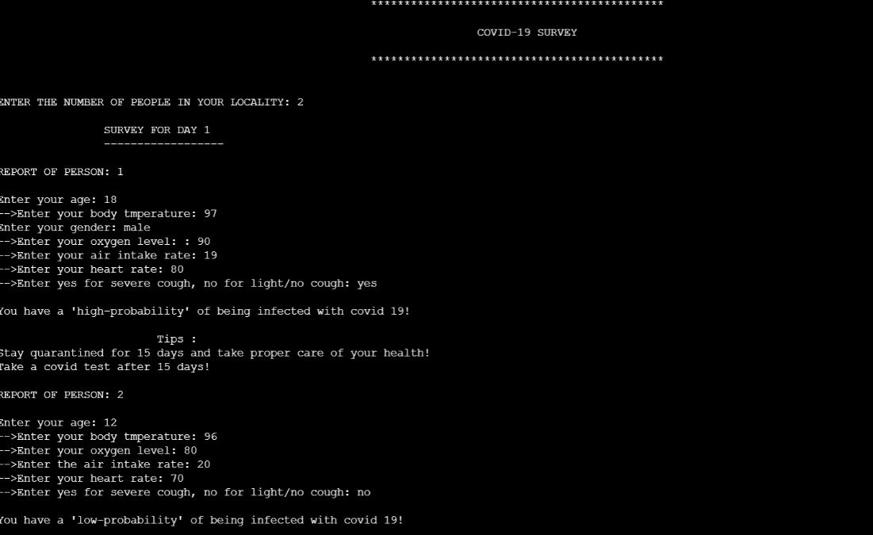

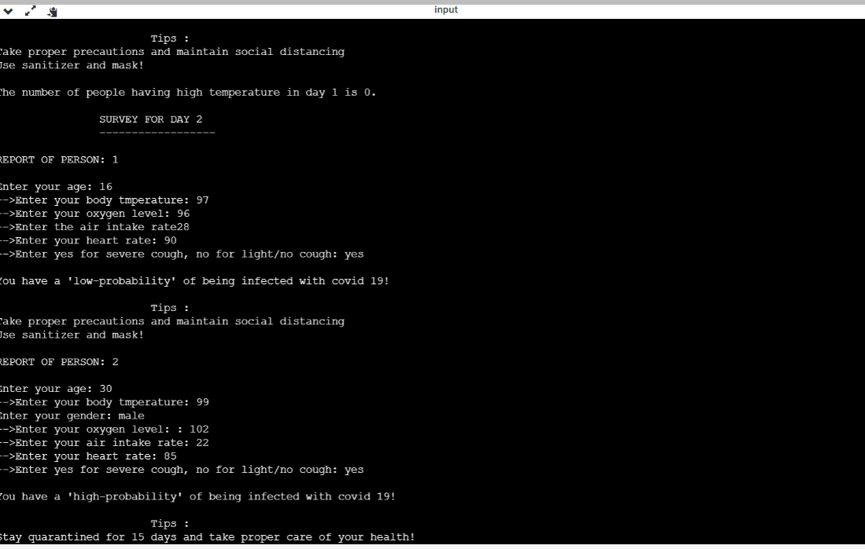

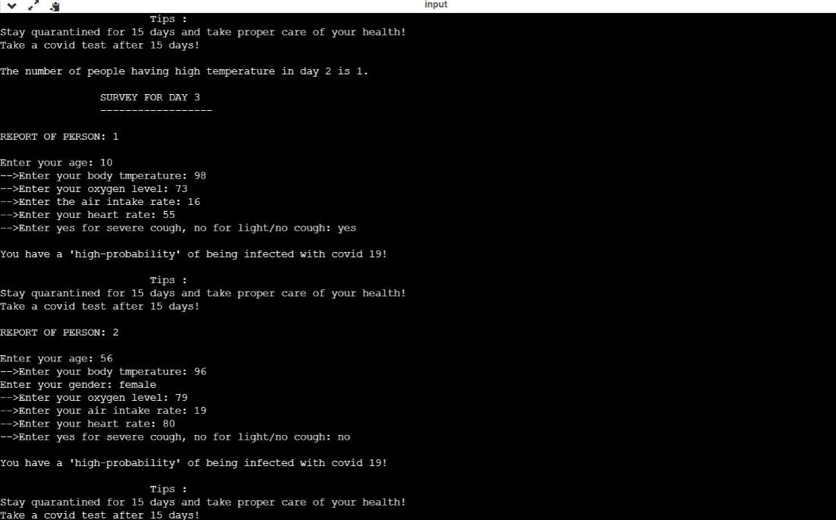

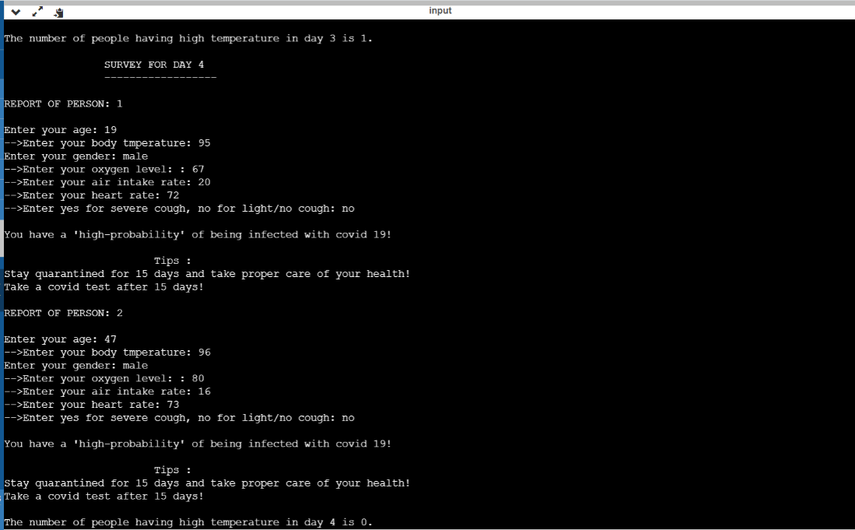

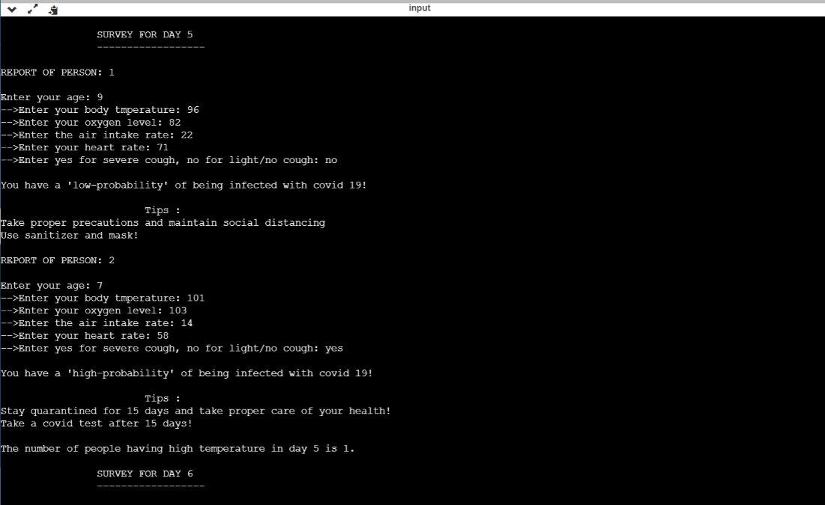

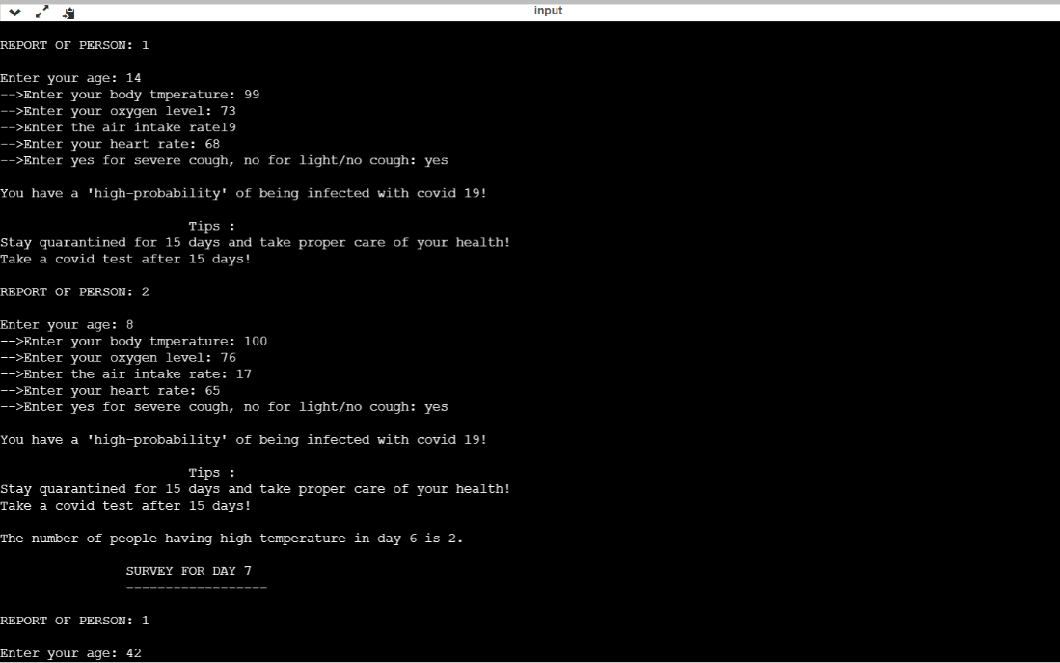

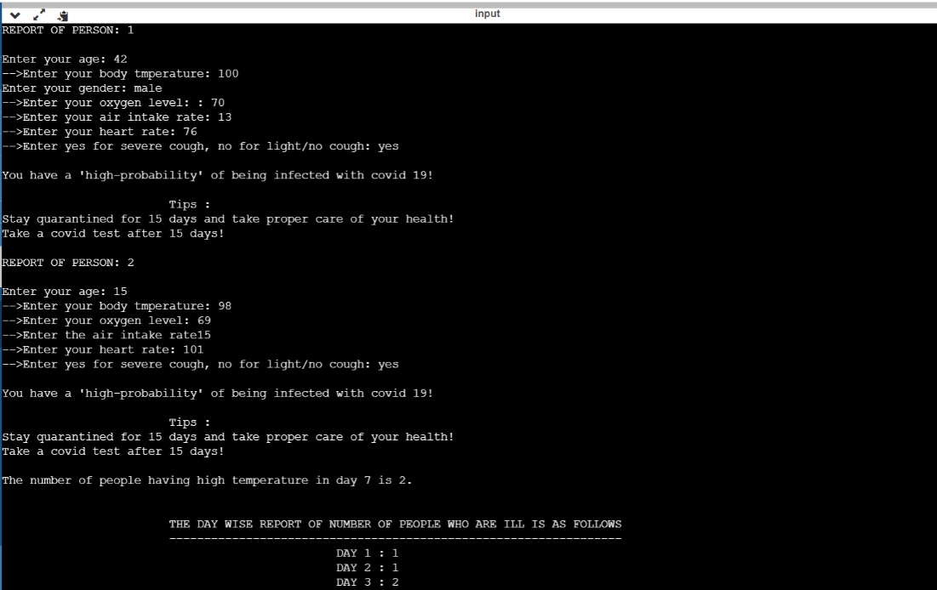

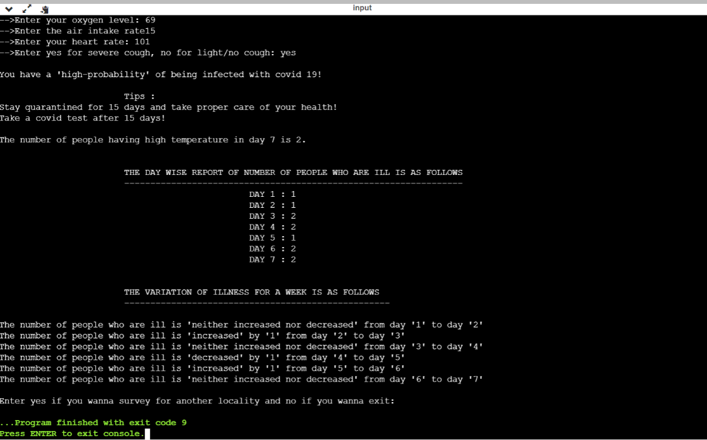

**Test case 2(For 2 persons)**

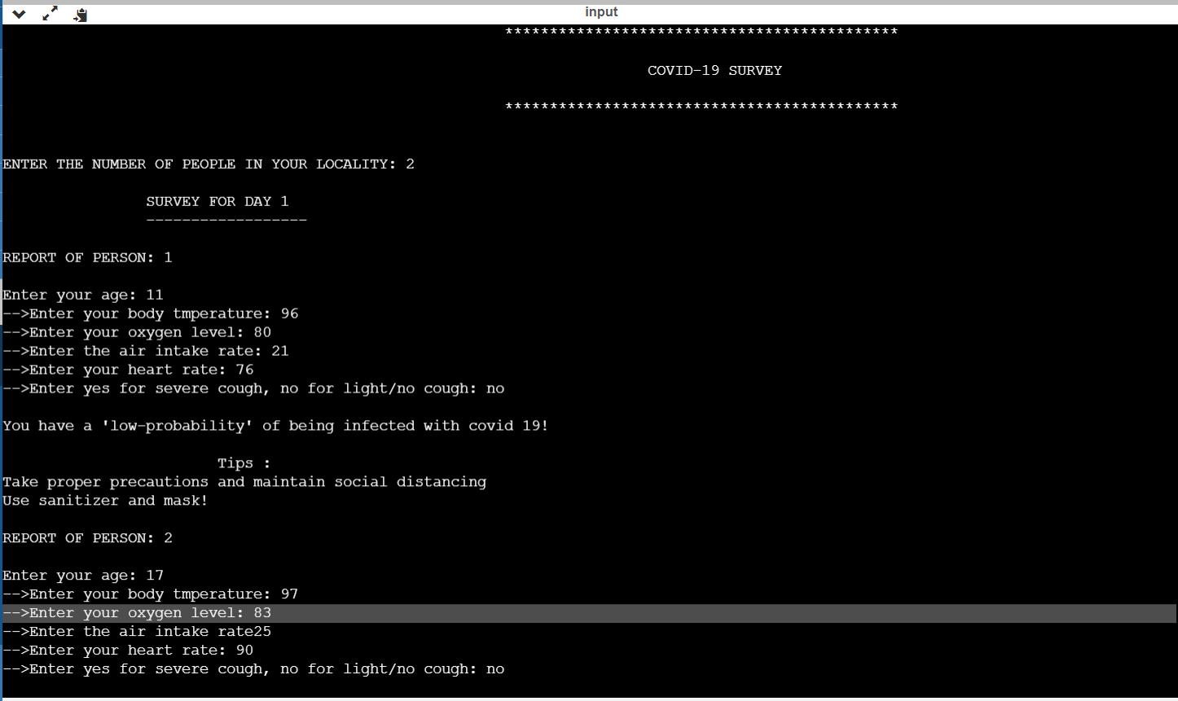

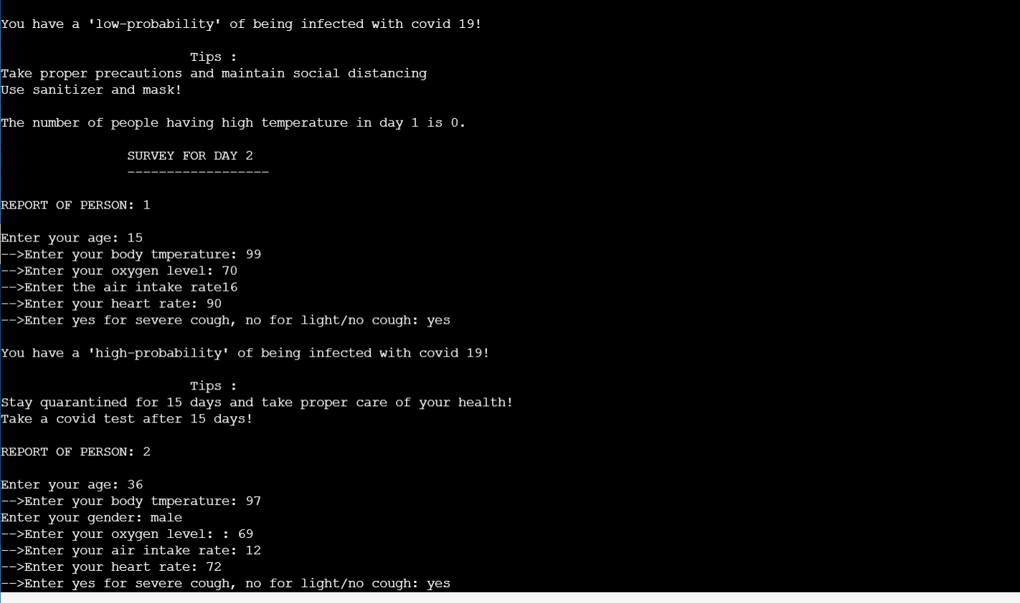

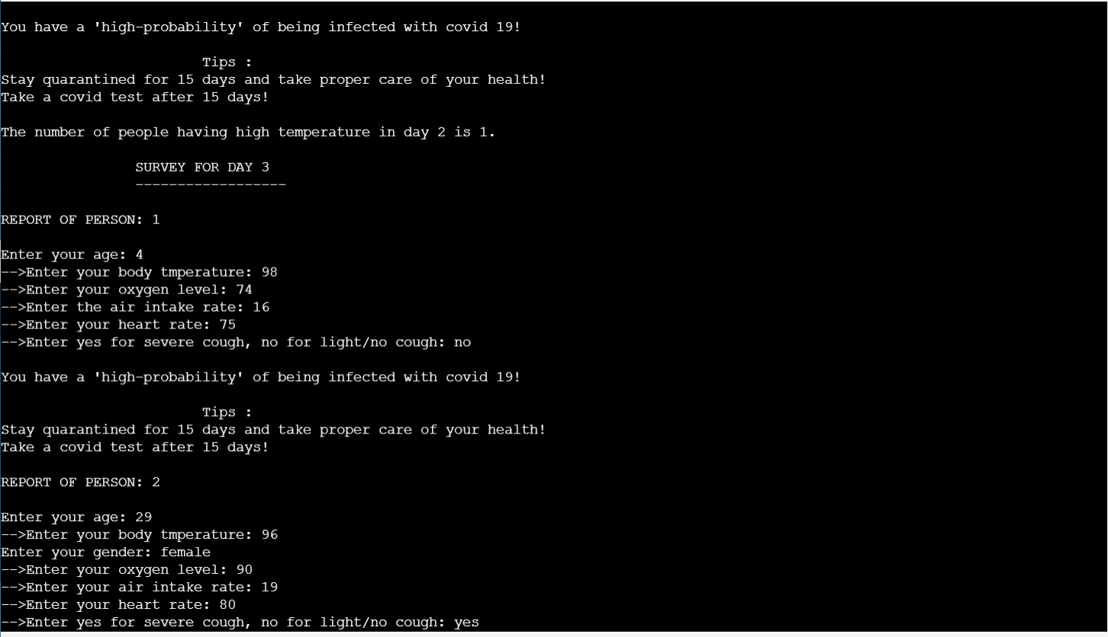

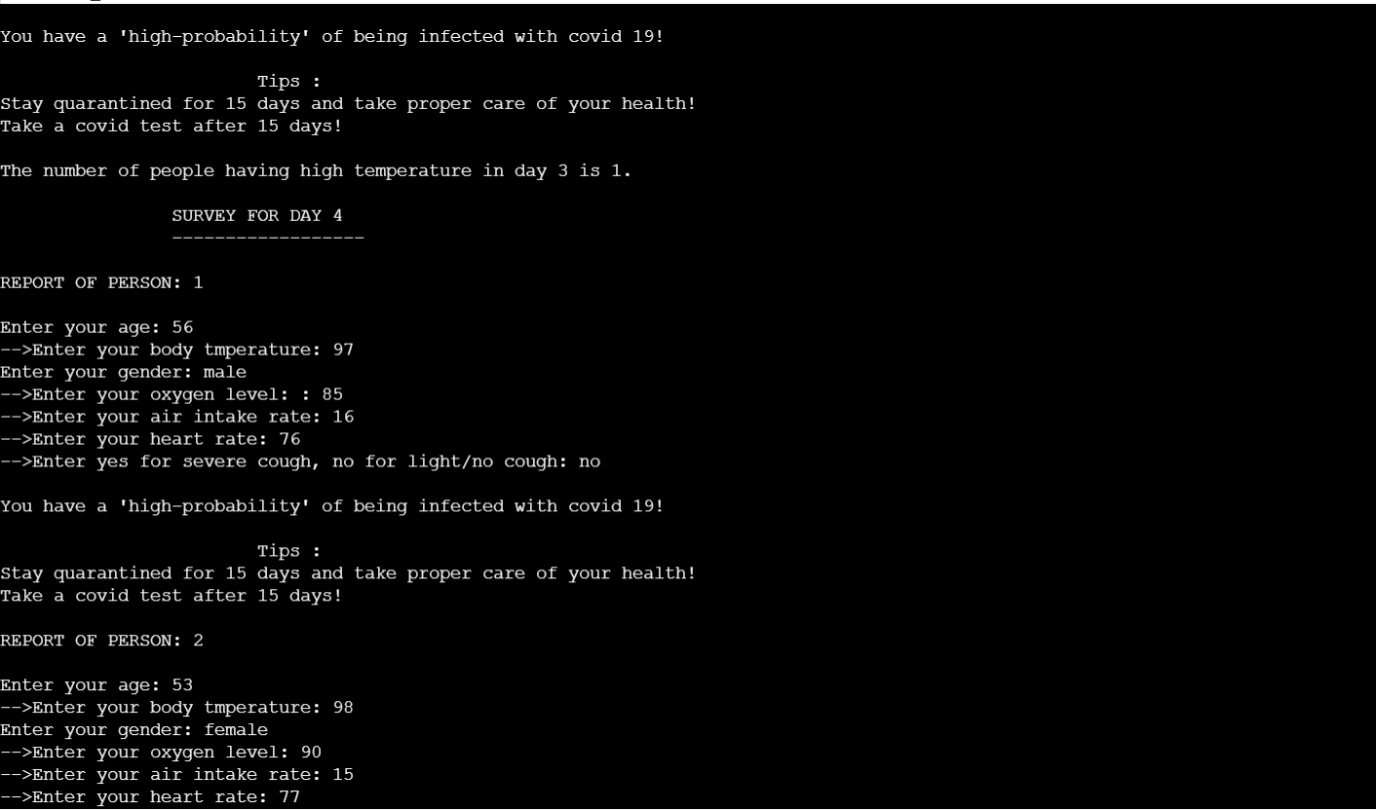

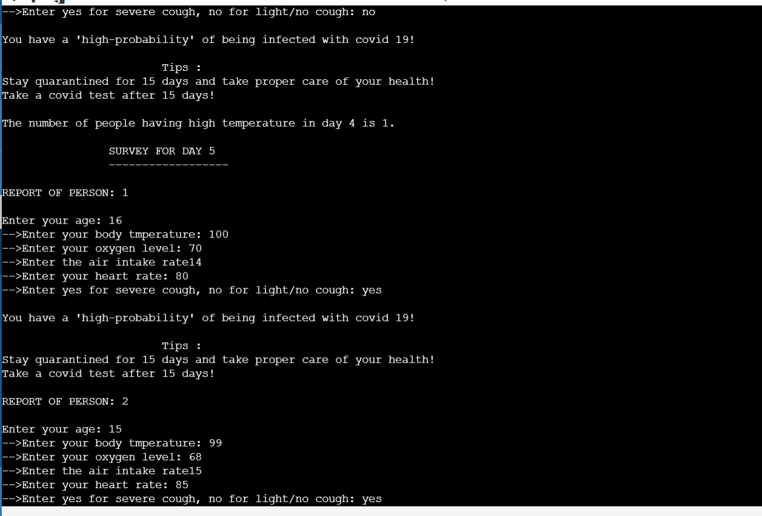

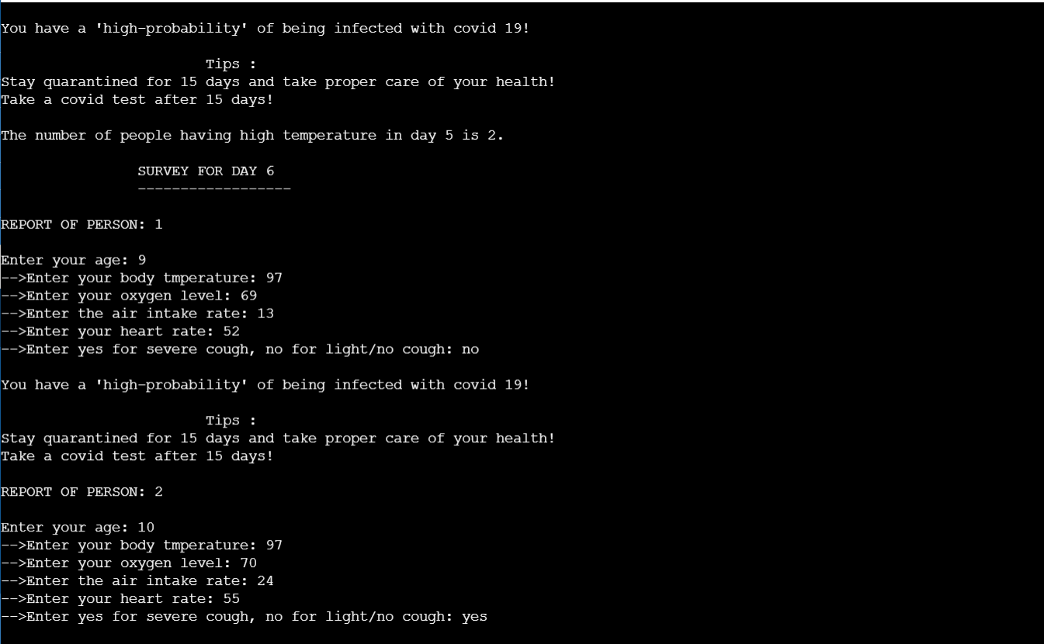

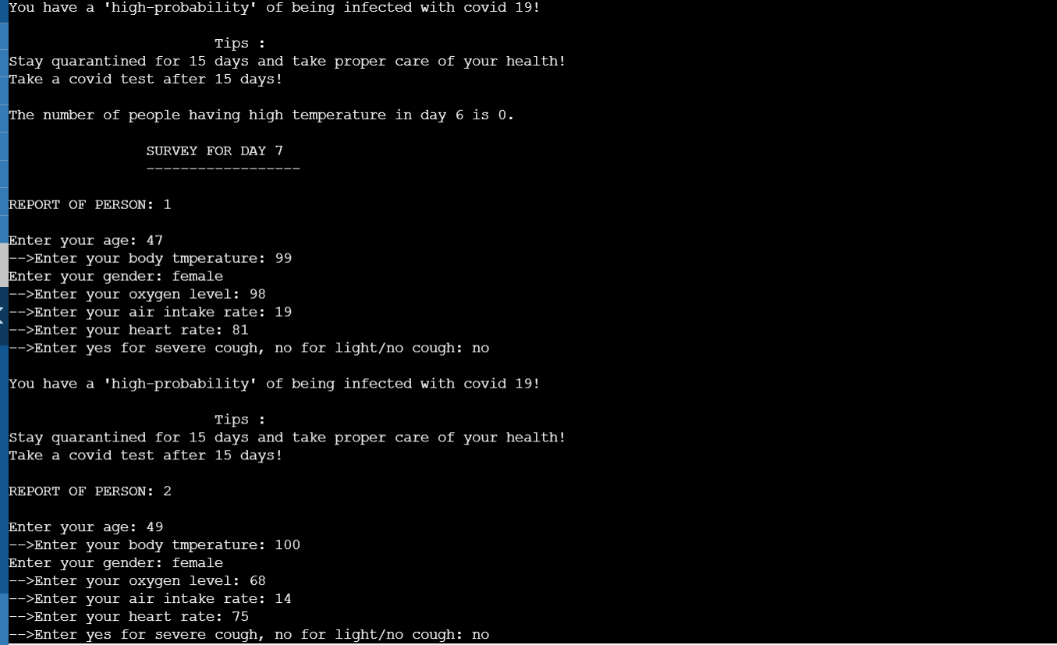

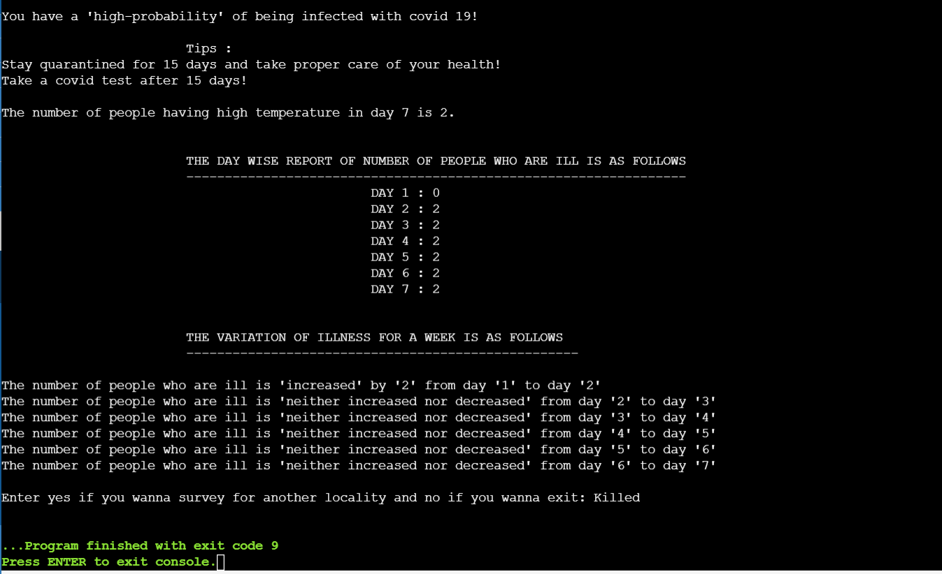

**Test case 3(For 3 persons)**

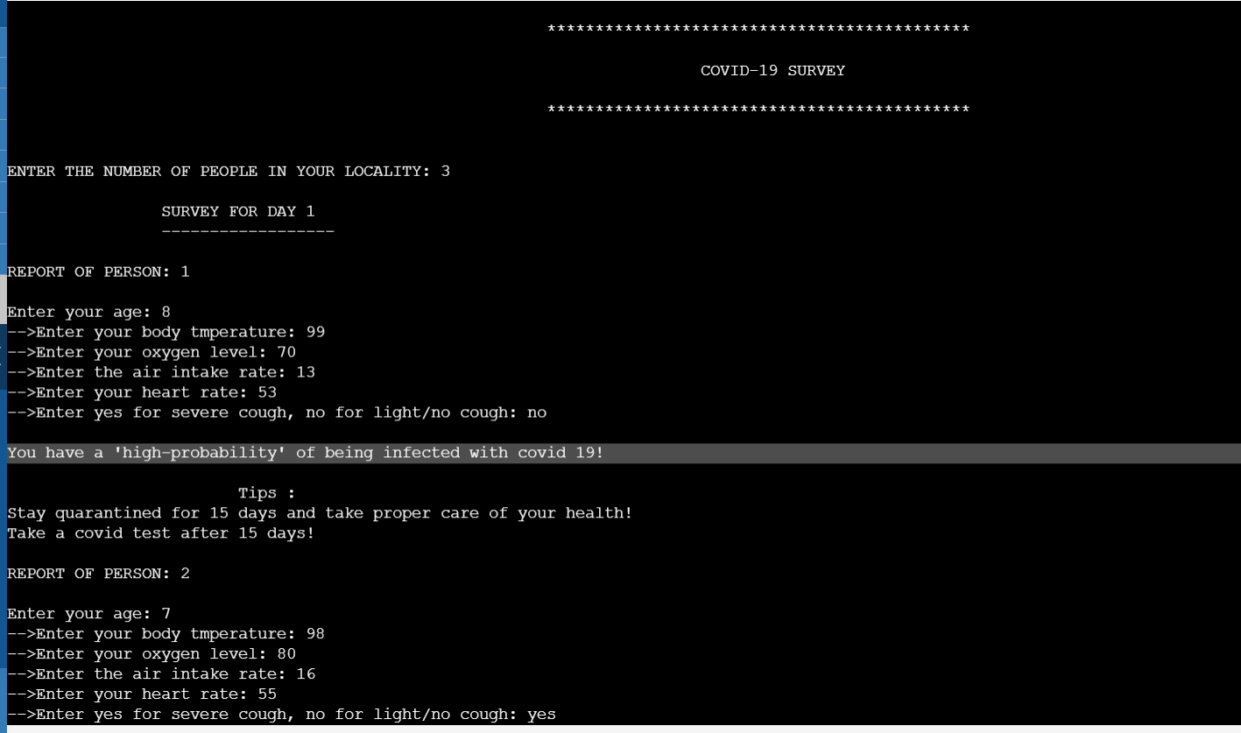

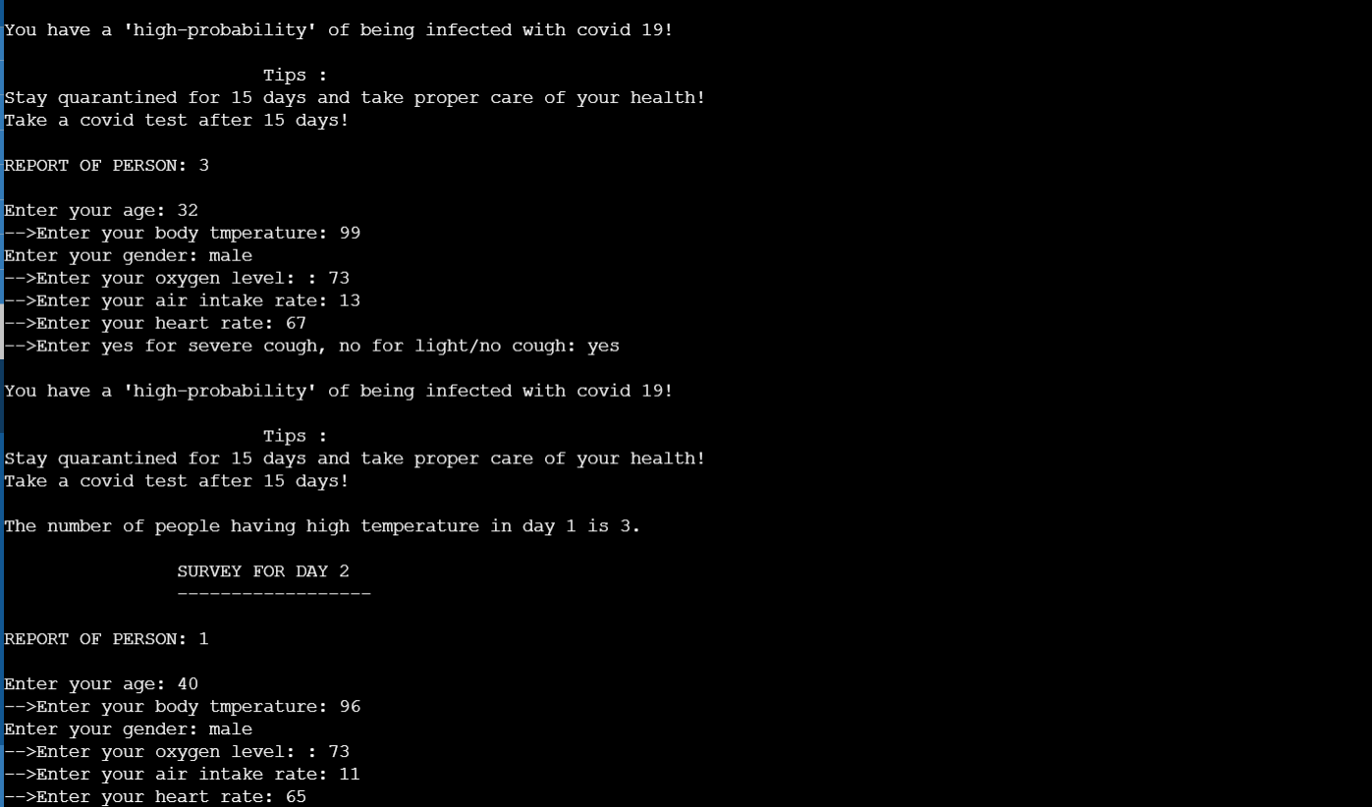

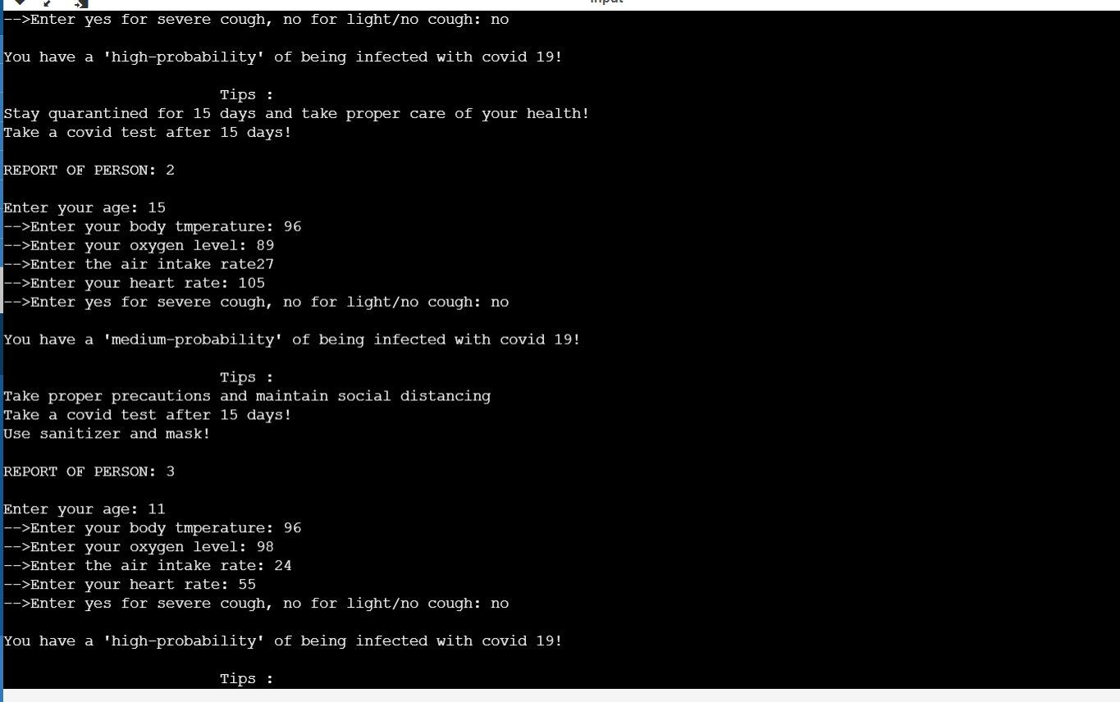

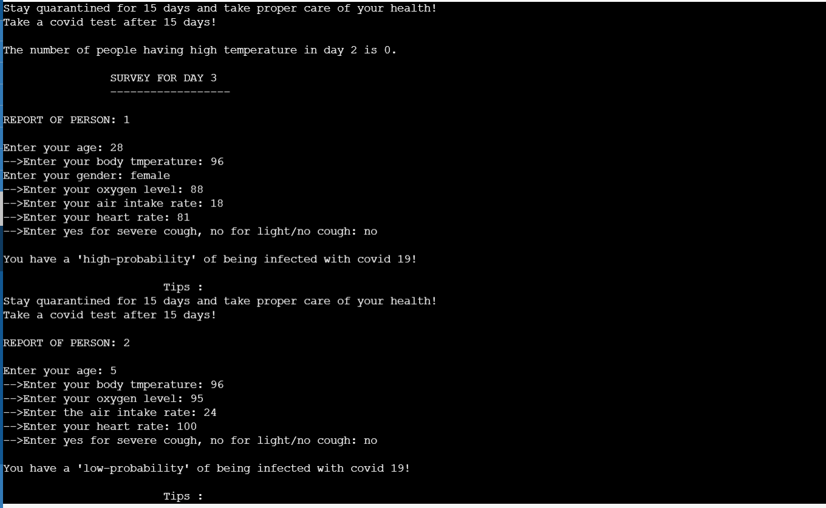

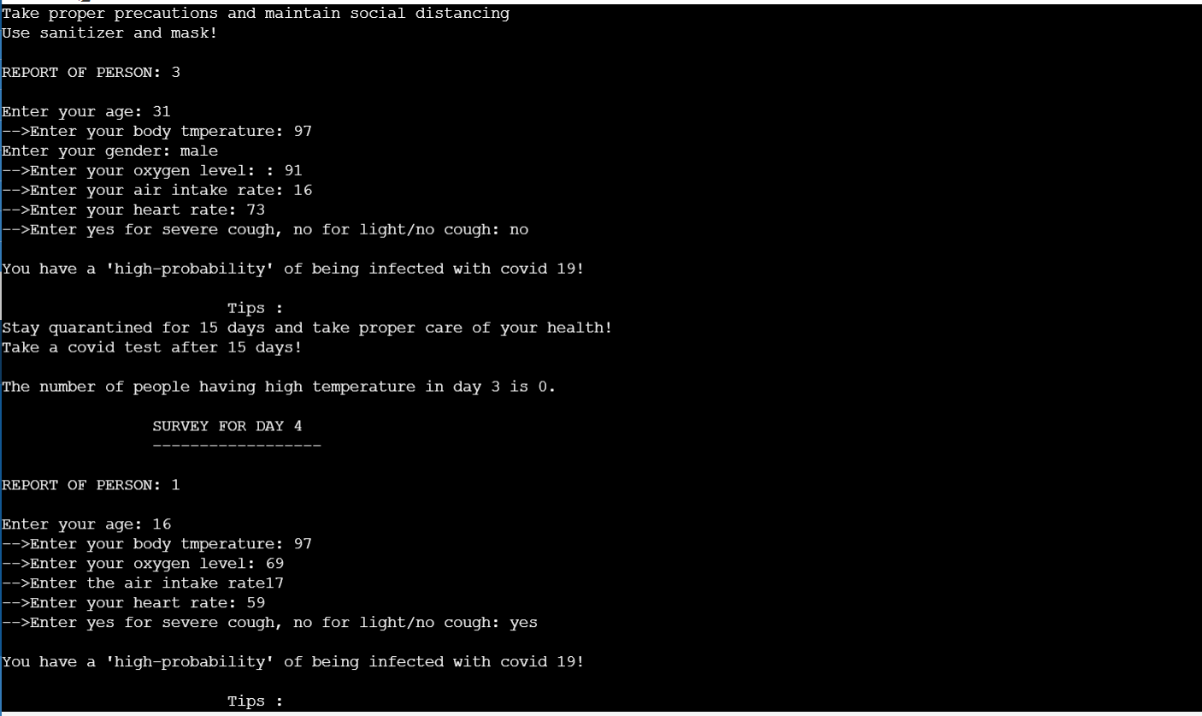

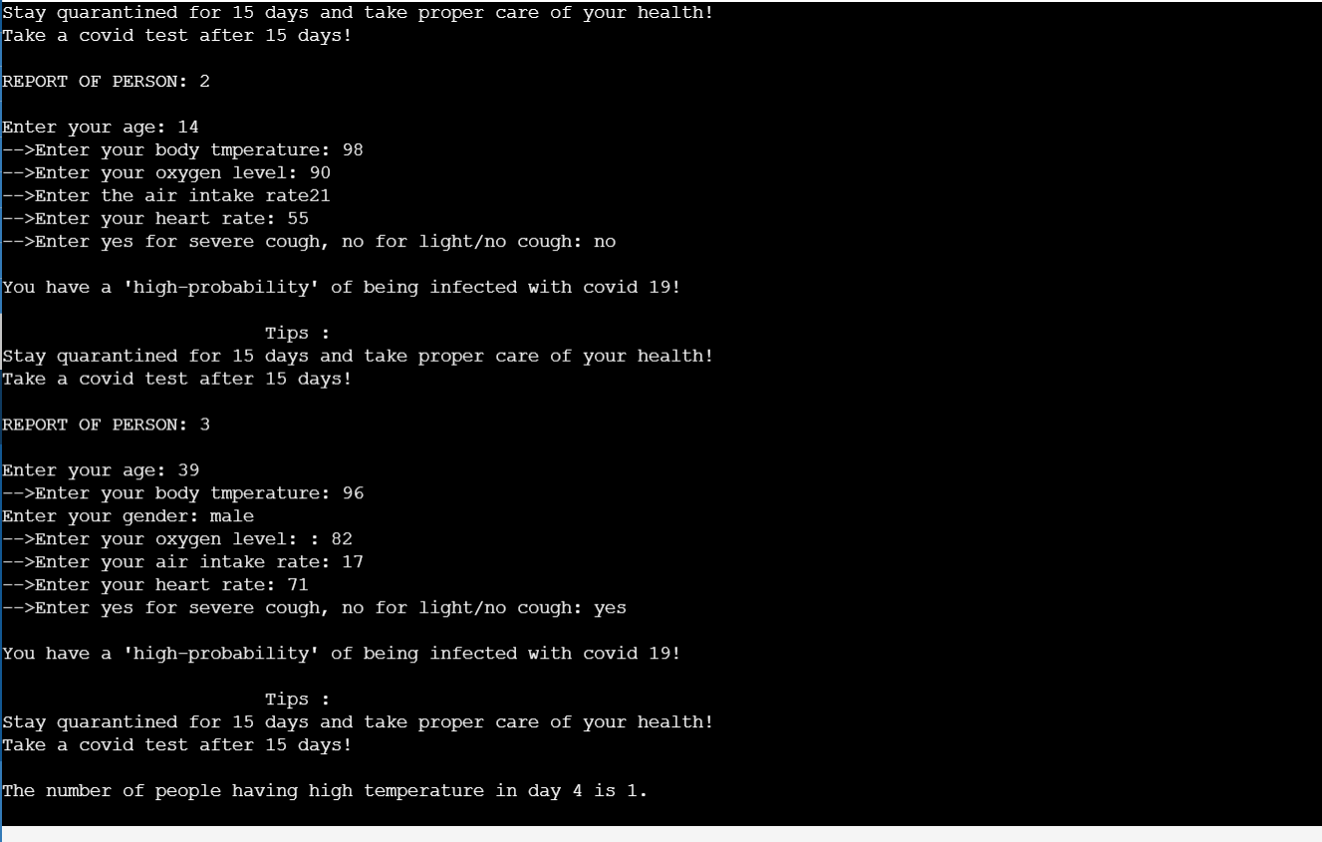

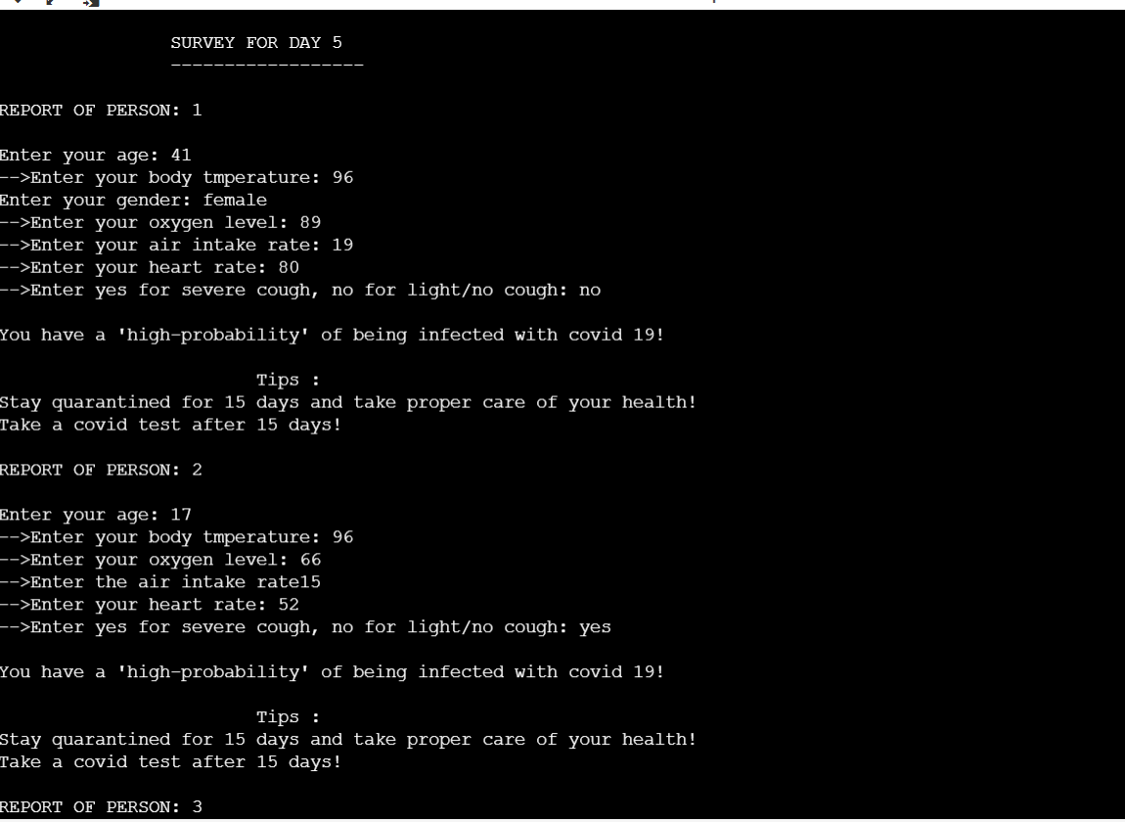

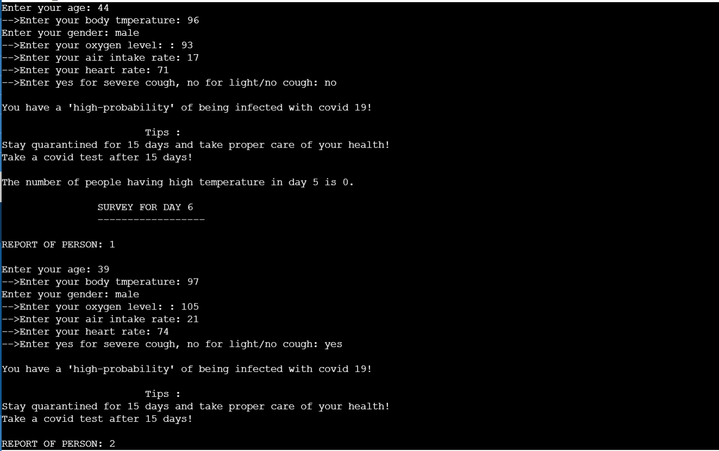

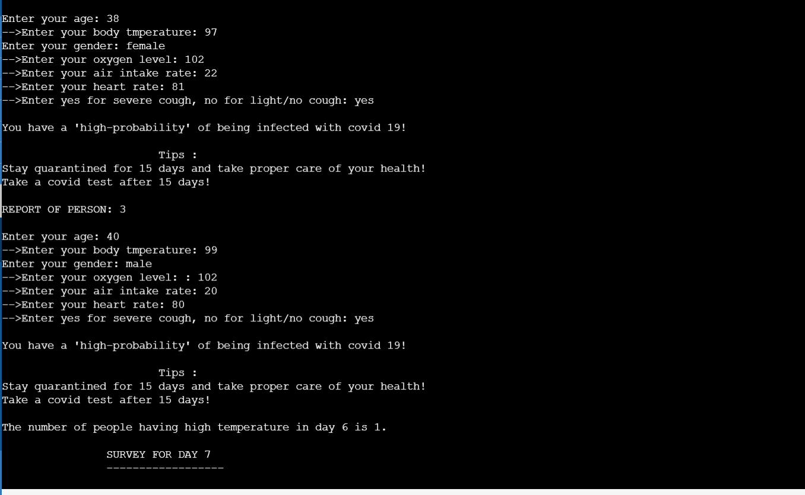

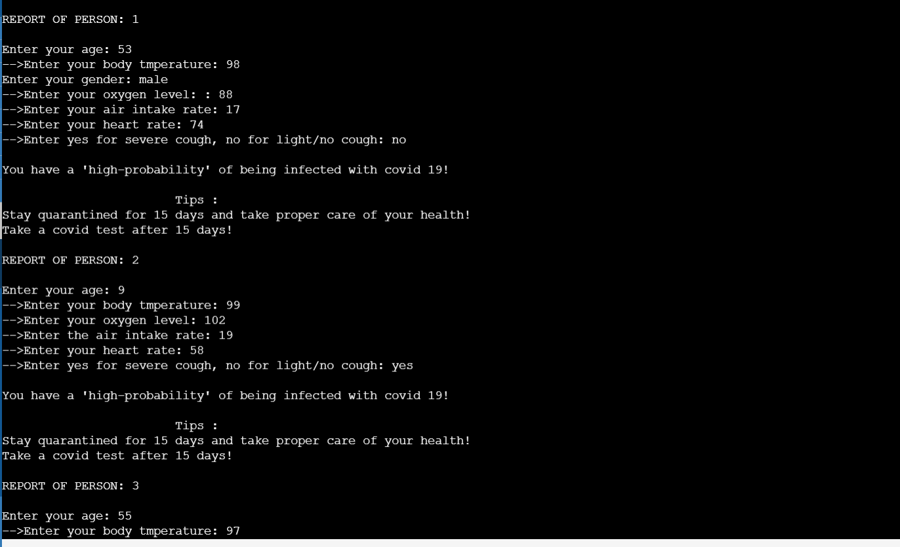

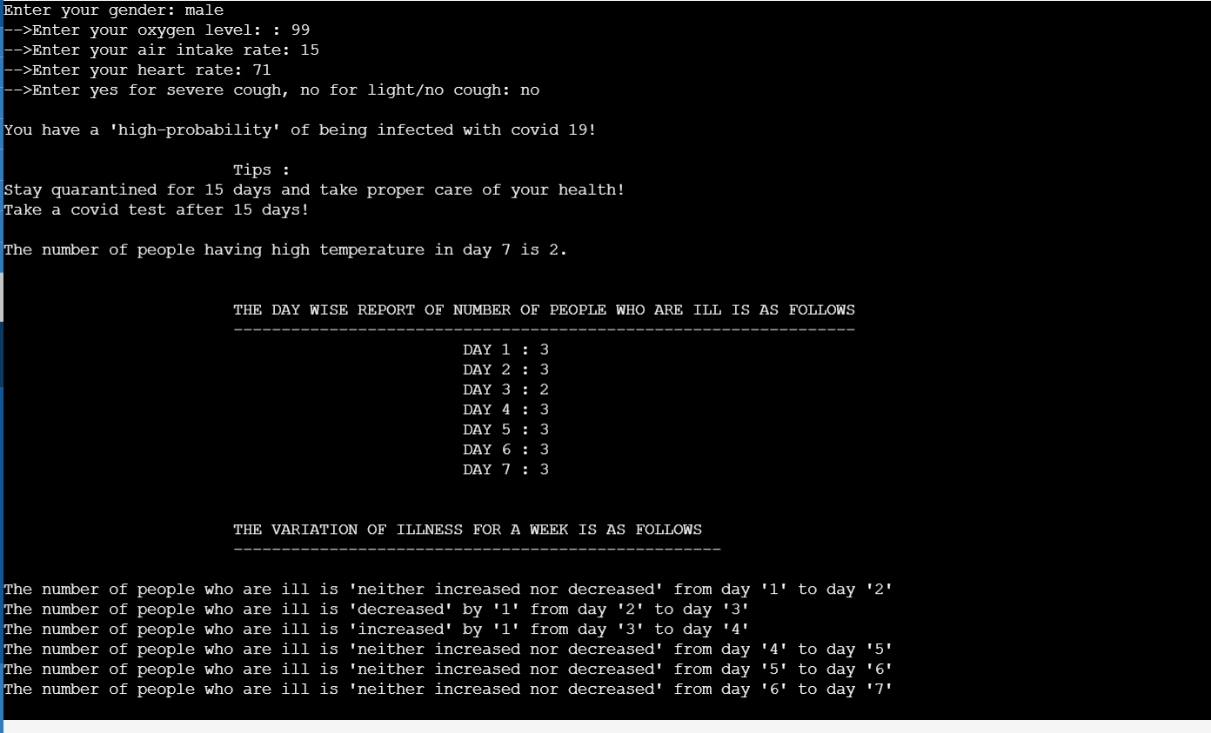

**Test case 4(For 3 persons)**

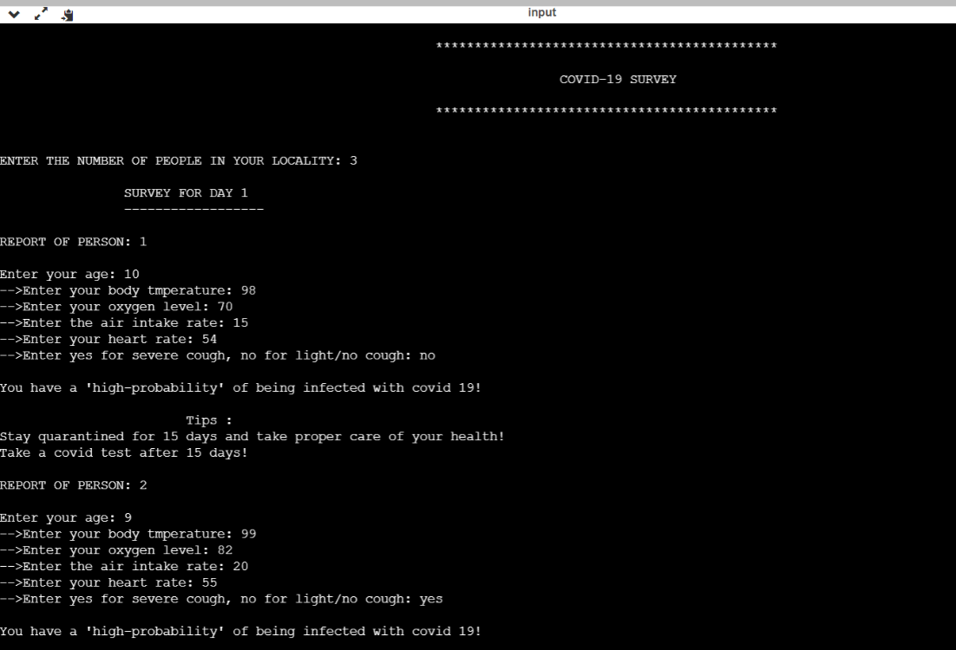

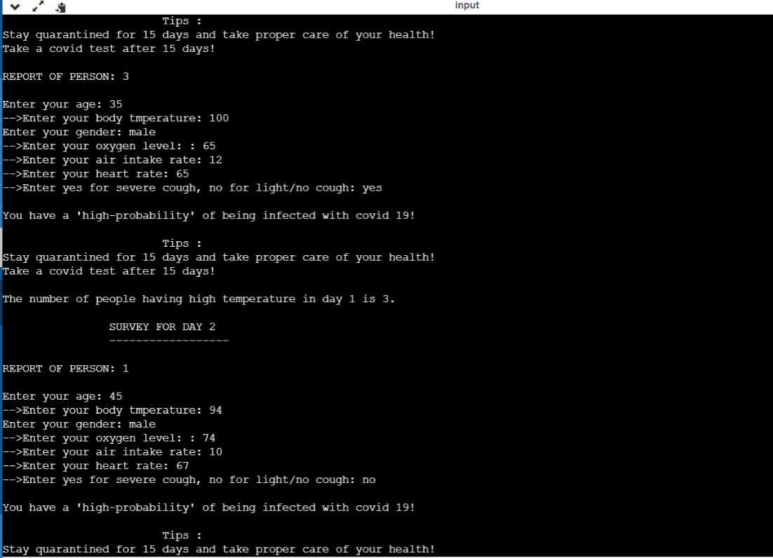

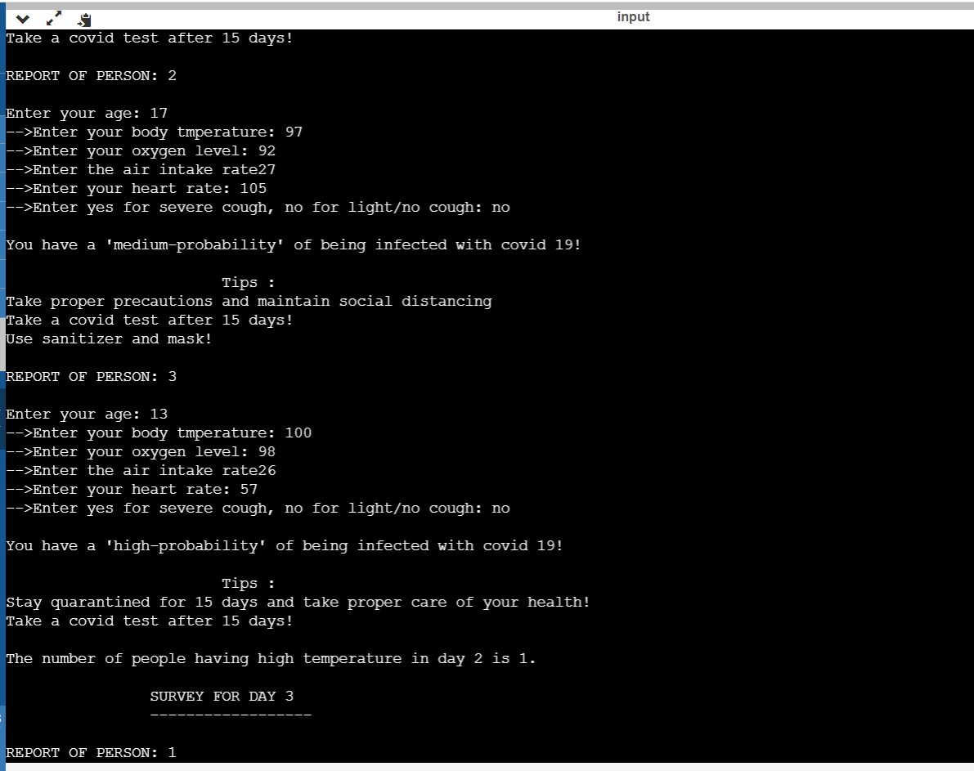

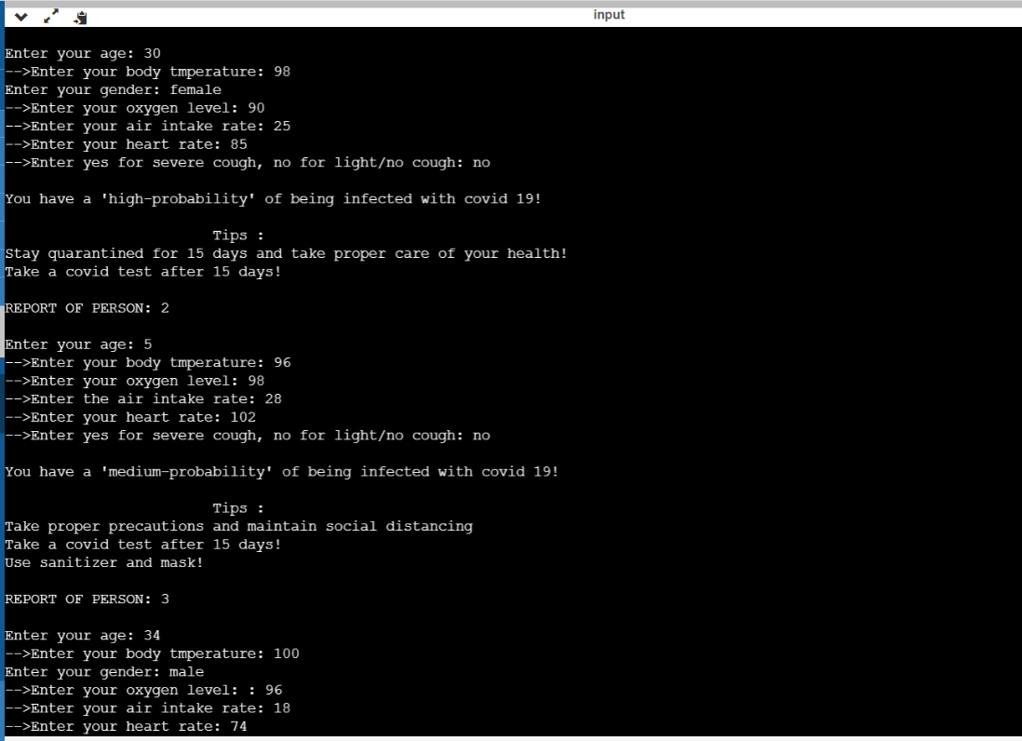

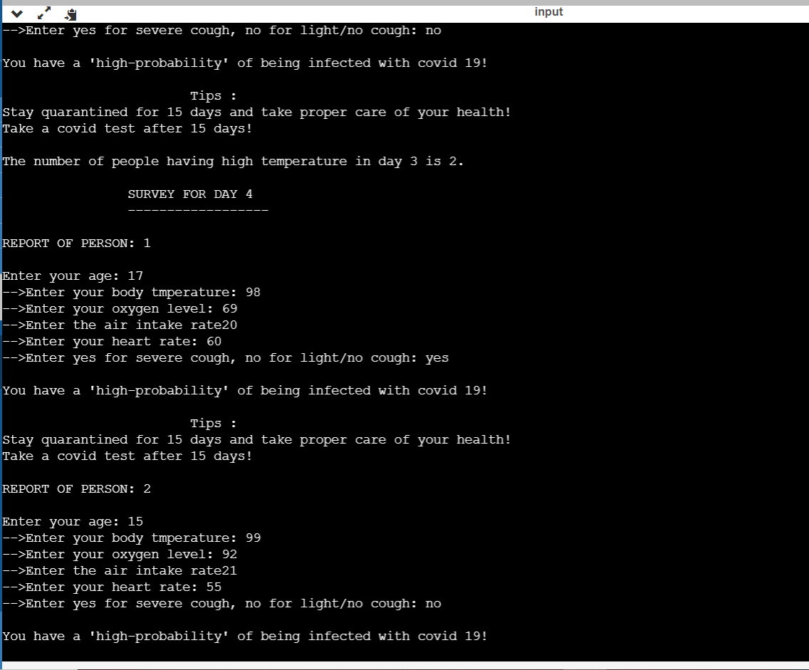

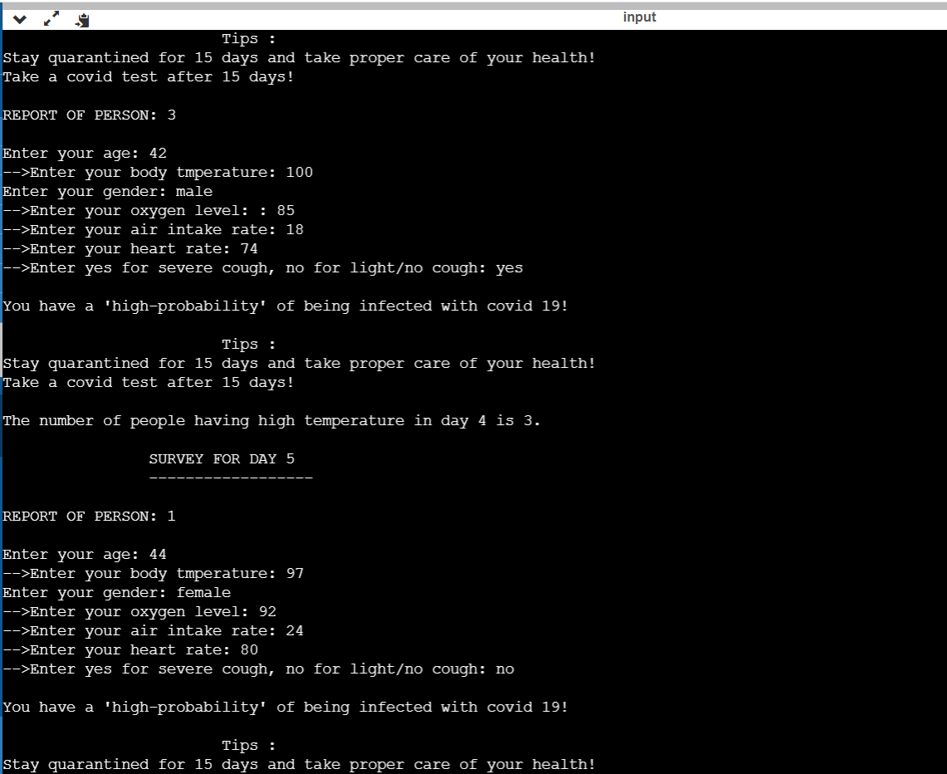

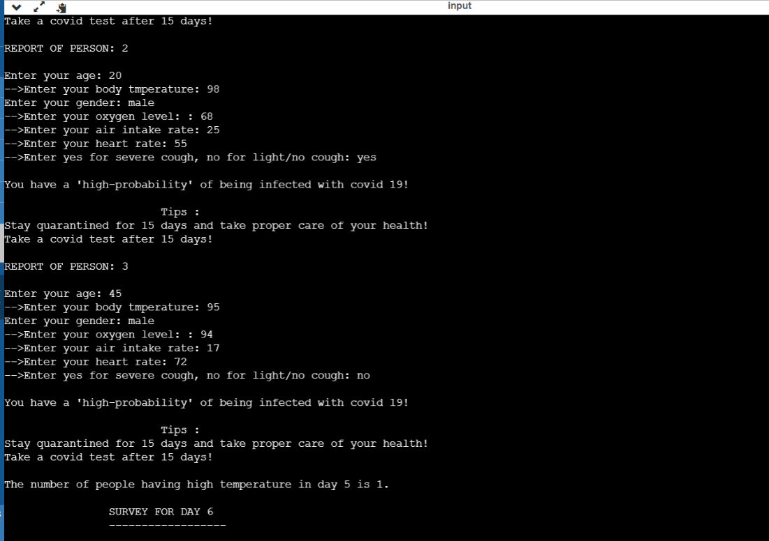

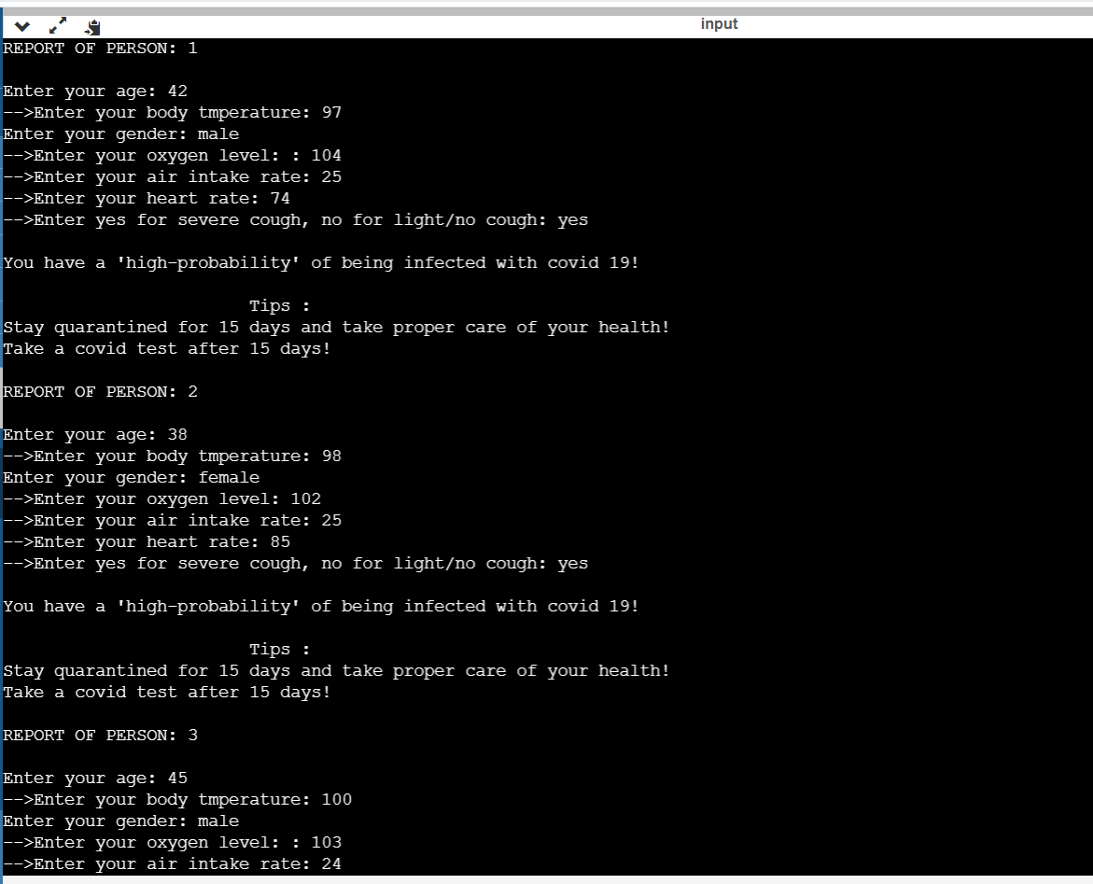

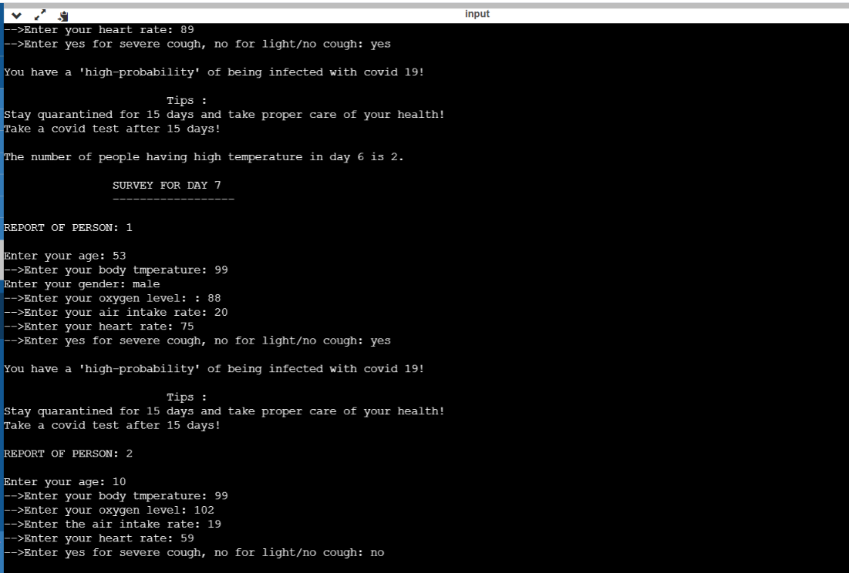

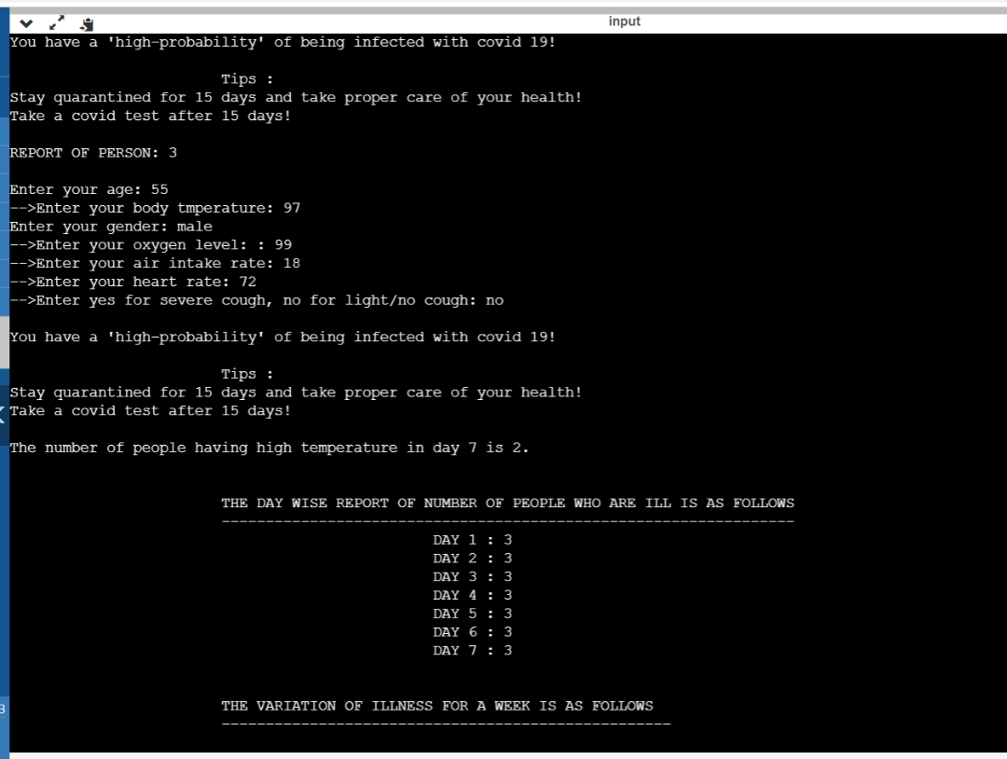

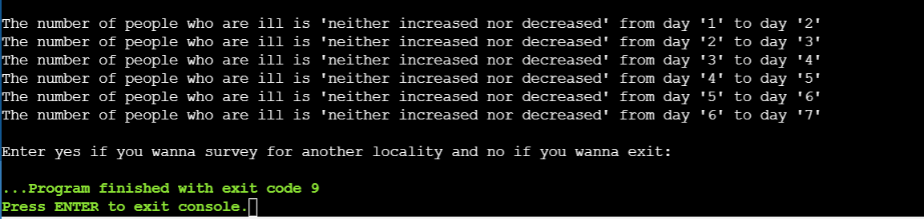

**Test case 5(For 4 persons)**

